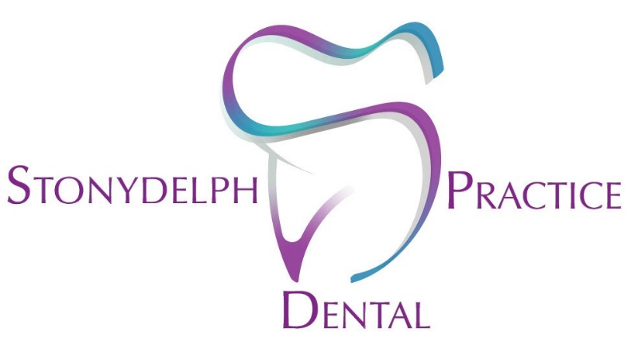
STONYDELPH DENTAL PRACTICE
ADVICE FOR DENTURES
GETTING USED TO YOUR DENTURES
If you’ve not worn dentures before you should give yourself time and patience to adapt and get used to them. At first you may feel as though they are too big for your mouth or that your lips are being pushed forward, you might also be concerned that they might fall out.
EATING
- Start with soft foods
- Cut your food up into small pieces and take your time
- Chew slowly using both sides of your mouth
- You may find sore spots as your denture ‘beds in’, contact the surgery for adjustments.
- You may find a fixative useful, although try to manage without if you can. Your mouth will adapt to eating with a denture after a while and with practice.
SPEECH
- Your speech may be temporarily affected, practice makes perfect! Your mouth will adapt to speaking with a denture quite quickly.
- You may find initially that you produce more saliva than usual, again this will settle as you get used to them.
CARING FOR YOUR DENTURES
- You can use a commercial cleaner such as Steradent (use to manufacturer’s instructions) before manually cleaning your dentures.
DO NOT USE STERADENT ON METAL DENTURES, only soap and water.
- Dentures are softer than teeth, and toothpaste can be abrasive and damage your dentures. Instead use normal soap. If you are wearing partial dentures use a SEPARATE toothbrush to the one you use IN your mouth.
- Clean your dentures over the sink with at least an inch of water in it (if you drop your dentures they are less likely to break.)
- We recommend that you sleep without wearing your dentures, so your mouth can rest, ( a bit like kicking your shoes off after a long day!). Unless otherwise advised by your dentist.
- When you are not wearing your dentures keep them damp (in a glass of water is ideal). If dentures are allowed to dry out they may become brittle and more likely to break.

